CD Store Use Case Document

October 26, 2015

Contents
Introduction 1
CD Online Store Use Case Diagram 1
UC1.0 Browse CDs 2
Overview 2
Actors 2
Preconditions 2
Basic flow 2
Alternate Flows 3
Post Conditions 3
UC2.0 Manage Shopping Cart 4
Overview 4
Actors 4
Preconditions 4
Basic flow 4
Alternate Flows 4
Post Conditions 5
UC3.0 Customer Registration 6
Overview 6
Actors 6
Preconditions 6
Basic flow 6
Alternate Flows 6
Post Conditions 7
UC4.0 Checkout 8
Overview 8
Actors 8
Preconditions 8
Basic flow 8
Alternate Flows 9
Post Conditions 9

Introduction
This document will detail the Use Cases for an online CD store system.

CD Online Store Use Case Diagram

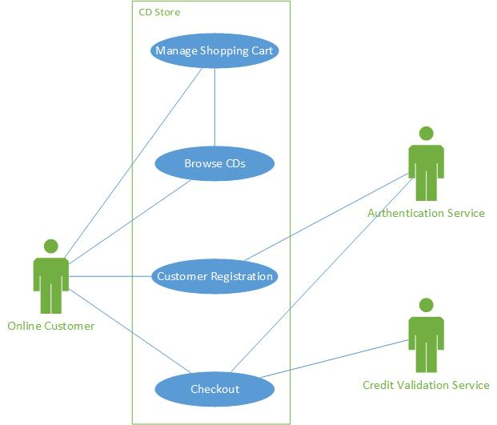
UC1.0 Browse CDs

Overview
The Browse CD use case is the Home page of the online CD store. From this page, customers will be permitted to browse available CDs based on various search criteria.

Actors
1. Customer.

Preconditions
Online CD store website is available.

Basic flow

1. Customer opens a browser and enters the online CD store URL.
2. The Home page of the web site is displayed.
3. Customer enters search criteria in the text box next to search icon and clicks on search icon.
4. The CDs matching the search criteria are then displayed on the Home page. For each CD listed,
the following information is displayed:
a. Name of CD (displayed as a hyperlink)
b. Name of Artist
c. Price
d.
5. Customer can sort the search results based on the following sort criteria:
a.
b.
6. Customer can click the hyperlinks in the search results to display details of the selected CD. The
following information is displayed on the Item detail page:
a. CD Title
b. CD Category
c. Description of the CD
d. Picture (if available)
e. Price per CD
f. Quantity requested
7. Customer can add CDs to the Shopping Cart by clicking the ‘add to cart’ button on the Item
detail page.
8. Customer can navigate from the Item detail page back to the Home page.

Alternate Flows
3.1 The message “No matching CDs were found” is returned if the search criteria the customer entered does not match any of the available CDs.

Post Conditions
- Home page displays the list of CDs that were retrieved based on the search criteria.
- The Item detail page displays detailed information about an individual CD that was selected on the Home page.

UC2.0 Manage Shopping Cart

Overview
The Manage Shopping Cart use case describes how the customer can add, edit or delete items from the Shopping Cart.

Actors
1. Customer.

Preconditions
The customer is viewing the Shopping Cart page.

Basic flow

- The user clicks on the Shopping Cart icon on the top right hand corner of the Home page or Item Detail Page.
- The Shopping Cart page is displayed with the items that have been selected from the Item detail page. The following details are displayed for each Item in the Shopping Cart:
- The name of the CD displayed as a hyperlink
- The quantity of each Shopping Cart Item to be purchased
- The unit price of each Shopping Cart Item
- The Shopping Cart page also displays the total cost of the items in the Shopping Cart.
- The customer can modify the quantity desired for each Item and the total cost displayed on the Shopping Cart is automatically updated.
- The customer can remove items from the Shopping Cart by clicking the “Remove” button next to the item no longer required. Once the button is clicked, the item is removed and the total cost is updated.
- The customer can view the detailed information of an item on the Shopping Cart by selecting the name of the CD. This brings the user to the Item detail page.
- The customer can return to the Shopping Cart by clicking the Shopping Cart icon in the top right hand corner on the Item detail page.
- The customer can proceed to purchasing the items in the Shopping Cart by clicking “Checkout”.

Alternate Flows
2.1 The Shopping Cart is empty and the following message is displayed “No Items selected”.
8.1 If the Shopping Cart is empty, the customer cannot proceed to Checkout.

Post Conditions
- Shopping Cart page displays CDs that were selected to be added to the Shopping Cart on the Item detail Page.
- The customer can successfully modify and remove items from the Shopping Cart.

UC3.0 Customer Registration

Overview
The Customer Registration use case describes the process of how new customers can register on the site or login if they are a returning registered customer.

Actors
- Customer
- Authentication Service

Preconditions
Online CD store website is available.

Basic flow

- The new customer clicks the registration icon on the top of the Home page or Item detail page.
- The Account Information page is presented to the customer.
- The new customer enters the following details in the Account Information page:
Contact Information:
- Username
- Password
- Confirm Password
- First Name
- Last Name
- E-mail address
- The customer clicks on Submit and the system validates all the customer information.
- If all information passes validation, the new account confirmation page is displayed.
- A confirmation email is then sent to the new customer.
- The new customer can then login to the CD store by selecting the Login option on the top right hand corner of the page.
- The customer is then presented with a screen prompting for username and password. Once entered, the customer clicks the “Login” button.
- If the login information provided passes validation, the customer is now logged into the CD store.

Alternate Flows
  - If the customer has already registered with the CD store then skip to step 7.
4.1 All fields are mandatory so if the customer fails to enter one, an error message will be presented indicating which fields are missing. The registration process cannot continue until all fields are populated.
4.2 The fields Password and Confirm Password must match, including case sensitivity.
9.1 If the username/password combination does not pass validation, an error message is presented to the user indicating that the username or password is invalid. The page is refreshed and the customer can then re-enter the username and password.

Post Conditions
- The new customer successfully registers with the CD store and can successfully login to the site.
- A returning customer can successfully login to the site.

UC4.0 Checkout

Overview
The Checkout use case allows customers to proceed with the purchase of the items in their Shopping Carts.

Actors
- Customer
- Authentication Service
- Credit Validation Service

Preconditions
The customer has items in the Shopping Cart, the Shopping Cart is being displayed to the customer and the customer is logged into the CD store.

Basic flow

- Customer clicks “Checkout” on the Shopping Cart page.
- Customer is then present with the Checkout page. The following information must be entered:
  - First Name
  - Last Name
  - Street
  - City
  - Province (drop down list)
  - Postal Code (A1A1A1 mask)
  - Country (drop down list)
  - Phone number (XXX XXX-XXXX mask)
  - Name on credit card
  - Expiration date (MM/YYYY mask)
  - CCV (3 digit number)
- Once all information is entered, the customer clicks “Place Order”.
- The system validates the information as follows:
  - All fields are populated
  - Field level formatting rules have been respected
  - Credit card validation service is called to ensure the credit card information is valid.
- If all information passes the validation step, the customer is presented with the Order Detail page. This page acts as the final step in the ordering process. The details of the order being placed is displayed. The information that is presented to the customer is the following:
  - Order Number
  - Order Status
  - First Name
  - Last Name
  - Street
  - City
  - Province
  - Postal Code
  - Country
  - Phone Number
  - List of the CDs being ordered:
    - CD Name
    - Quantity being ordered
    - Price
  - Total cost of the order
- If the order is correct, the customer clicks the “Confirm Order” button in order to place the order.
- If the order is successfully processed, the Order Confirmation page is presented to the customer. This page contains the following information:
  - Order Number
  - Order Status
  - First Name
  - Last Name
  - Street
  - City
  - Province
  - Postal Code
  - Country
  - Phone Number
  - Name on the credit card
  - Credit card number (all numbers are represented by X’s except the last 4 digits)
  - List of the CDs being ordered:
    - CD Name
    - Quantity being ordered
    - Price
  - Total cost of the order
- An email is then sent to the customer with the information contained on the Order Confirmation page.
- The customer can then return back to the Home page.

Alternate Flows
4.1 An error message is presented to the user with details of the validations that have failed. The processing of the order cannot continue until all input errors are resolved.
6.1 If the customer notices that there is an error in the information that was inputted, the customer can return to the Checkout page and edit the entered information.

Post Conditions
- The customer successfully purchases the items in the Shopping Cart.

